Welcome!
Date
Name
Spouse
Address
City
State Zip _________
Email

Please Contact By
❑ Card  Phone  Visit

Telephone Best Time to Call
Home ______________
Work ______________

Guest: First Time Second Time
Are you a church member: yes no
Church
City, State

Circle Appropriate Age/Grade Group(s)
Preschool: Ages: B-1 2-3 4-5
Children: Grades: K 1 2 3 4 5 6
Youth: Grades: 7 8 9 10 11 12
Adults: Ages:18-29 30s 40s 50s 60s+

How did you learn about our church?
Newspaper Friend Yellow Pages Mail
Other

I am a guest of:

New in the Community? Yes No
Names & ages of children at home

Weekly Service & Activity Schedule

Jan 29, 2017
9:45 a.m. Sunday School
11:00 a.m. Worship Service
6:00 p.m. Evening Worship

Week of Jan 29, 2017

Wednesday 6:30 pm………………..…Meal/Bible Study

February
5……………………………………New Commandment Kids
9……………………………………………….Adult Fellowship
12…………………………………..New Commandment Kids
12……………………………..…………Valentines Luncheon
12………………………..…………………..Business Meeting
19……………………..…….Gideons International Speaker


Every Sunday Morning @ 9:45



Join us Sunday Feb. 12 after the worship service for the annual Valentines Pot Luck Luncheon. Bring your favorite person AND your favorite dish.

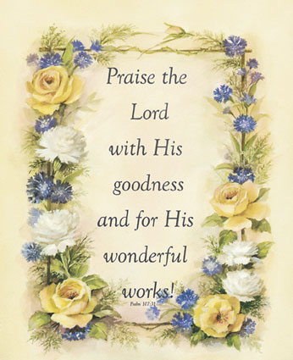

Knobbs Springs Baptist Church

January 29, 2017

Church Information:

KnobbsSpringsBC.com KnobbsSpringsBaptist@gmail.com

1662 CR 305, McDade, Texas 78650 512-273-2743

David Atwood, Pastor Cell 512-470-5098

Patti Radford, Office Manager Cell 512-968-7821

